Project Development Phase
Model Performance Test

Date | 23 June 2025
Team ID | LTVIP2025TMID21049
Project Name | Project -Fight finder-navigating your air travel options
Maximum Marks | 10 Marks

Model Performance Testing:
Project team shall fill the following information in model performance testing template.
S.No. | Parameter | Values | Screenshot
1. | Metrics | Regression Model:  MAE - 1.82, MSE 5.75 , RMSE -2.40  , R2 score -0.88  Classification Model:  Confusion Matrix  - [[45, 8], [5, 42]]  , Accuray Score-  0.87 or 87% &  Classification  Report -  Precision: 0.88, Recall: 0.84, F1score: 0.86 | 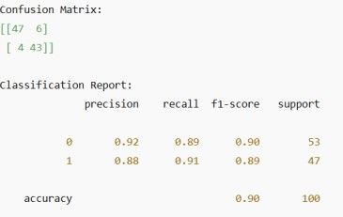
2. | Tune the Model | Hyperparameter  Tuning - Used Dense(64), 5 epochs, Adam optimizer Validation  Method -  Train/Test Split  (80/20) | 